**SOFTWARE REQUIREMENT SPECIFICATION DOCUMENT FOR**

**ONLINE SHOPPING MART**

**By**

**DINESHKUMAR M**

**Software Requirement Specification (SRS) report for Online shopping System**

**Abstract:**

The Online Shopping System is needed to make a user-friendly online store. In today's digital world, online shopping is super important for buying things. The main aim of this project is to make an online shop that's easy to use for everyone.

It'll have lots of products to choose from, easy buttons to click on, safe ways to pay, and quick ways to manage orders. And also the people in charge will have tools to keep track of everything they're selling.

**SDLC-Software Development Life Cycle**

Software Development Life Cycle (SDLC) models are methodologies used by software development teams to design, develop, test, and deploy software applications.

**Iterative Model:** The Iterative Model involves repeating a set of development activities in cycles or iterations.

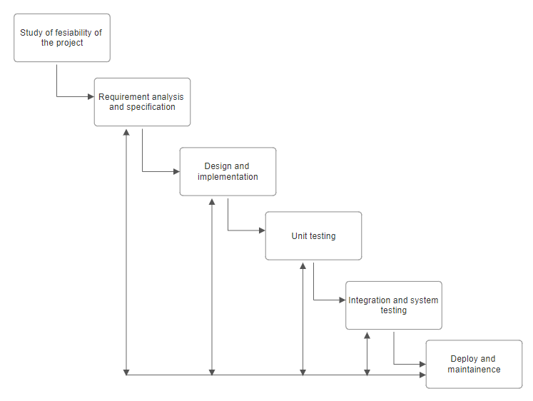

**Specific requirements**

**Functional Requirements:**

1. **Administrator:**
   * **Database Management:** Control and maintain the database containing records of customers and employees.
   * **Vendor Management:** Communicate with vendors, test their products, and grant permission for them to sell on the site.
   * **Access to All Details:** View all employee details and have overall control of the site.
   * **Site Advertising:** Create and manage advertisements to promote the site.
2. **Customers:**
   * **Login:** Customers need a valid login ID to access the site.
   * **Registration:** New users can create a new ID to sign up.
   * **View and Edit Personal Details:** Customers can see and update their personal information, payment details, and service preferences.
   * **Product Selection and Comparison:** Customers can browse and compare available products before making a purchase decision.
   * **Purchasing:** Customers can buy products using a valid credit card.
   * **Feedback:** Customers can provide feedback to the 24x7 Customer Care Service about their experience with the site and its services.
   * **Logout:** Customers should log out of the site after completing their purchase.

**3.Visitors**

* **Visiting the page:** Can only visit the site without registration and can buy items only if signed in**Top of Form**

**Non-functional Requirements:**

**1.Performance Requirements:**

* The system should handle a large number of items and users without any issues.
* When users request to view information, it should appear on the screen within 5 seconds.

**2.Safety Requirements:**

* Using the system should not cause any harm to human users.

**3.Security Requirements:**

* The system will use a secure database to store data.
* Regular users can only read information and cannot edit or modify anything except their personal details.

**Operating Environment**

Hardware Requirements:A PC with proper speed and memory.

SoftwareRequirementsFrontEnd:PHP:HTML,CSS,Javascript,HypertextPre-processor

BackEnd: SQL Database

**Modular Description:**

**1.Customers module:**

**Login:** Users will need to enter their username and password to access the system.

**Registration Interface:** Users will provide personal details such as name, username, password, date of birth, address, and registration type.

**Viewing products**: The customers can view the product and it’s details by clicking on it.

**Add to Favourites:** Users can mark their favourite items to create a list for easy reference in the future.

**Cart:** This is where customers can store items they intend to purchase. Users can add or remove items from their cart before proceeding to checkout. Once they decide to purchase the items in their cart, they will be directed to the payment page to complete the transaction.

**Payment:** Users will be presented with various payment options, including online payment via credit/debit cards, net banking, mobile banking, or cash on delivery.

**Order tracking:** It handles the tracking of the order which gives clear perspective about shipping and where the order is. Through this, we can track our order.

**Customer Service:** It facilitates customer support and service functionalities. It aims to enhance customer satisfaction, resolve issues promptly, and foster positive relationships between the business and its customers

**2.Administrator module:**

The administrator will use a unique login ID to access their account, which includes a control panel providing access to various aspects of the system. In this control panel, the administrator can:

Access Customer Database: View and manage information related to customers stored in the database.

Manage Vendor Database: View vendor details, review requests for shop creation, and respond to them with acceptance or dismissal.

**System architecture:**

**Flowchart**

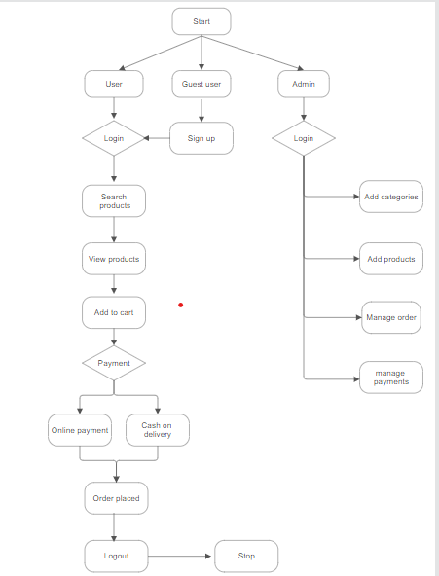

**Use case diagram**

A use case diagram is a graphical representation in the Unified Modelling Language (UML) that illustrates the interactions between actors (users or external systems) and a system or software application.

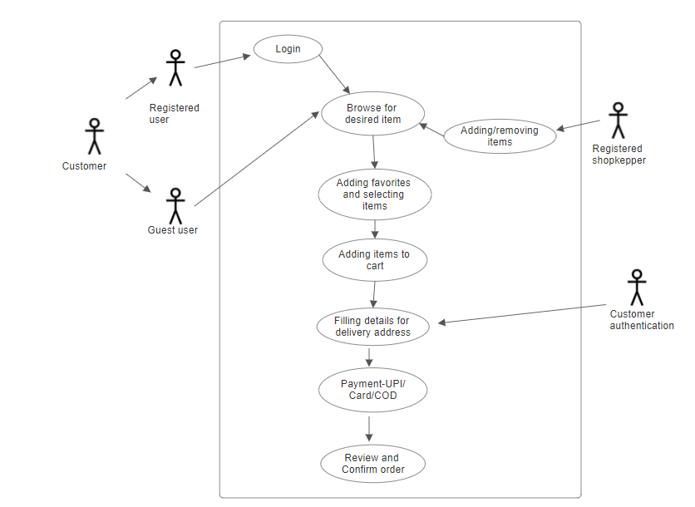

**Sequence Diagram**

A sequence diagram is a type of interaction diagram in the Unified Modelling Language (UML) that illustrates the interactions between objects or components within a system over time. Sequence diagrams are used to visualize the sequence of messages exchanged between objects or components in a particular scenario or use case.

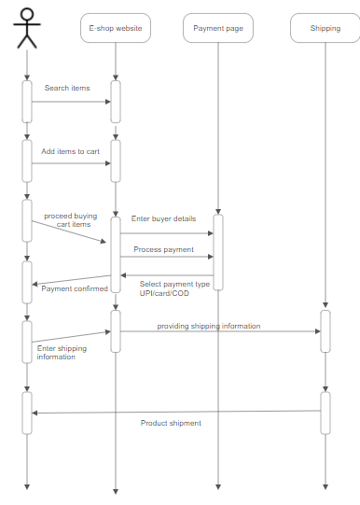

**Class Diagram**

A class diagram is a type of diagram in the Unified Modelling Language (UML) that illustrates the structure and relationships of classes within a system or software application. In software engineering, classes represent the building blocks of object-oriented programming (OOP), encapsulating data attributes and behaviours (methods or functions) related to a specific concept or entity.

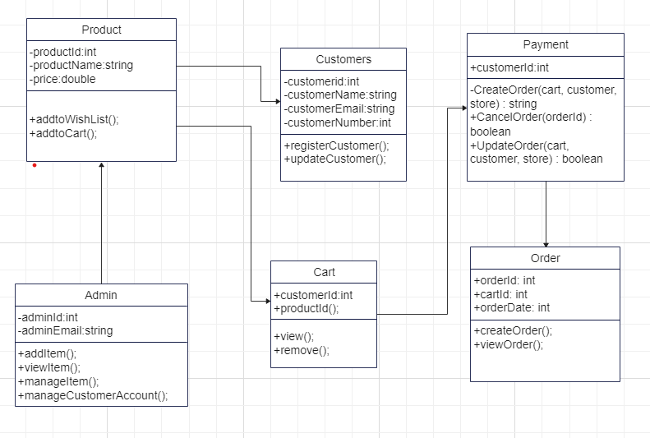

**Conclusion**

In conclusion, the Software Requirement Specification (SRS) for the Online Shopping System lays out the essential features and technology needed to build a user-friendly e-commerce platform. This document serves as a blueprint for creating a smooth and secure shopping experience for customers and provides administrators with tools for managing inventory and orders efficiently.